Accessing the Axiom Environment for the First Time
You have been added to the Axiom system as a user. Below are the links to the production environment. Please follow the instructions below to access Axiom.
Note that some of the steps below (installing software on your computer) will require that you have administrator rights on your computer. If you do not have admin rights, call HelpDesk to perform the installations.
If you have any issues connecting, please reach out to the University Budget Office (ubo@seattleu.edu).
Axiom supported browsers:
Microsoft Edge
Google Chrome
Internet Explorer is no longer supported by Axiom
- Go to MySU and choose the Axiom button.
  - When you click the link, you should see a login screen open

- Enter your normal SU credentials and click Sign In.
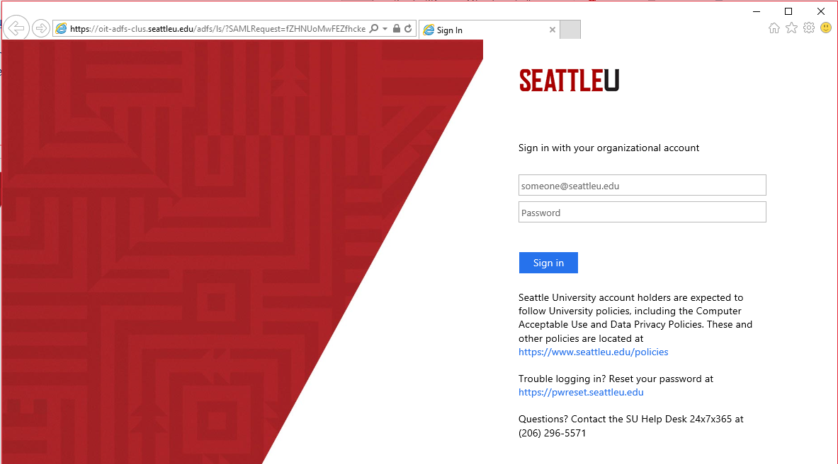

- After you sign in, the Axiom Landing Page appears.
  - If you get any login error such as cannot validate user name or password, contact the University Budget Office (ubo@seattleu.edu).
  - If the Axiom Landing Page does not appear, and it seems that nothing at all has happened, it is likely that this is because your computer has been recently refreshed. If this is the case, the ITS team will need to load an additional piece of software to your computer.
Contact the Help Desk with this information:
    - Request: Have desktop support technician install .NET 3.5 to enable Axiom to launch correctly from the browser. This is a known issue and desktop services requested that users who experience this problem submit a help desk request so a technician can change a registry setting and install the correct .NET version.
    - Office location
    - Computer name (go to mypc.seattleu.edu to look up)
    - Dates and time available for a short appointment (note that the user will need to be logged in to verify it works, so any assistants helping a dean/cabinet member should be prepared)

- You may now access all the features available in the web client of Axiom which include Budget Transfers and Budget Entries.
**Note: The first time you use the “Create a Budget Transfer/Entry” buttons you may need to disable a pop-up blocker on your computer. If nothing appears to happen when you choose one of the “Create” buttons, look to see if there is a small icon in the upper right corner of the web browser address bar indicating that your computer has blocked a pop-up. Click on this and choose to disable the pop-up blocker for Axiom.

- To access Operational Budgeting and Labor Planning choose the Windows Client button on the Axiom Landing (Home) Page.
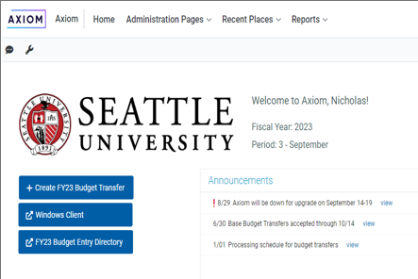

- The Axiom Install / Launch Application page will open.
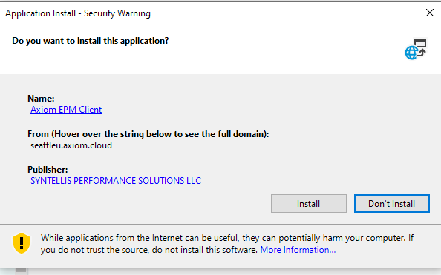

- Click on About in the Navigation Pane on the left on the Axiom Home Page
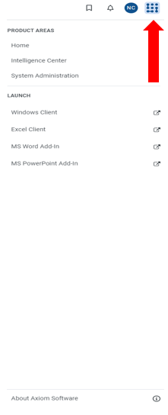

- Click on the Necessary software tools for running Axiom desktop client applications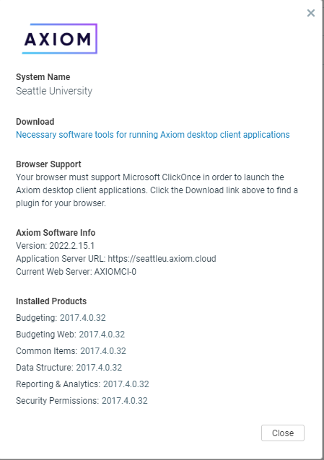

- Click on ClickOnce Helper for Google Chrome and the Chrome web store window will open.
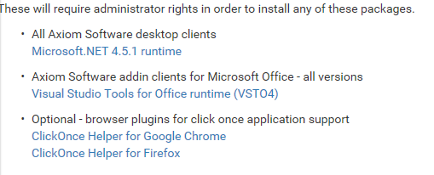
- In the ClickOnce for Google Chrome offered by Meta4 area click the “+ ADD TO CHROME” box.
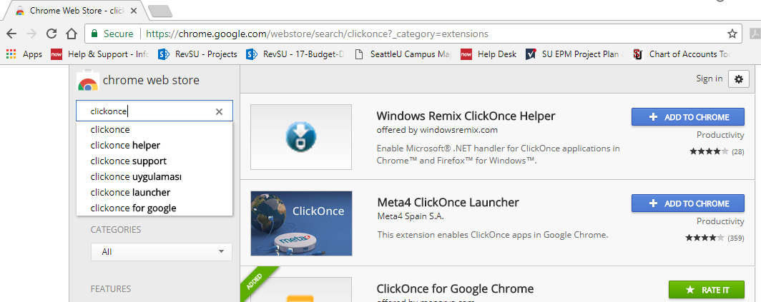

- Choose “Add extension” when this window appears.
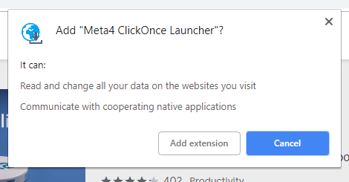

- A new tab will open that looks like this
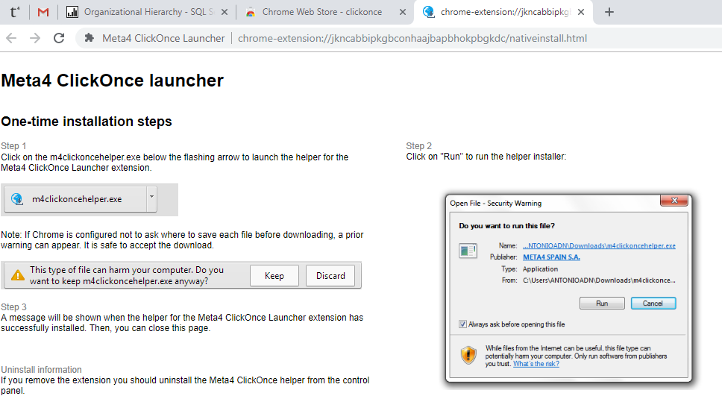

- Close this tab by clicking the “X”

- You will now be back on the Chrome Web Store page.

- Click the back arrow two times to return to the Axiom Install / Launch Application page
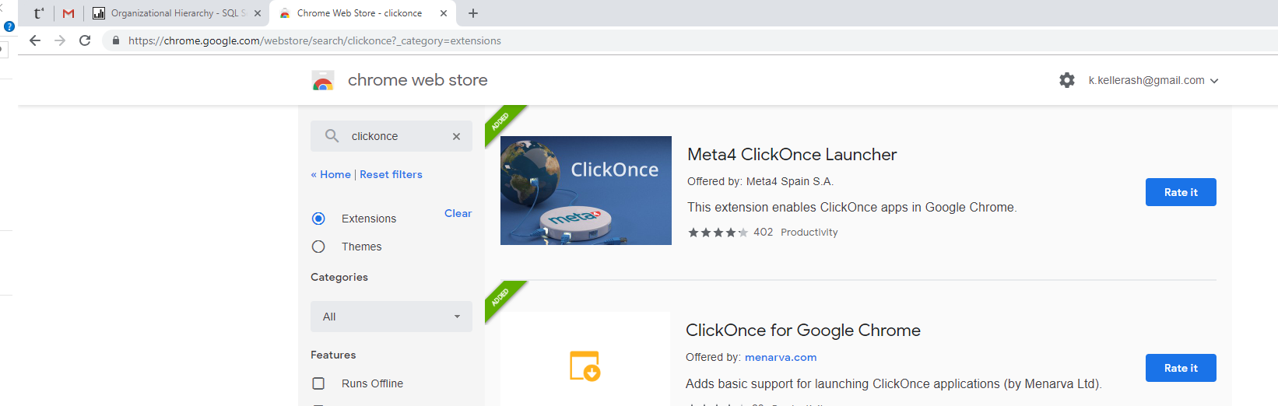

- Click on the Windows Client Icon
- The Axiom Quick Links page will appear
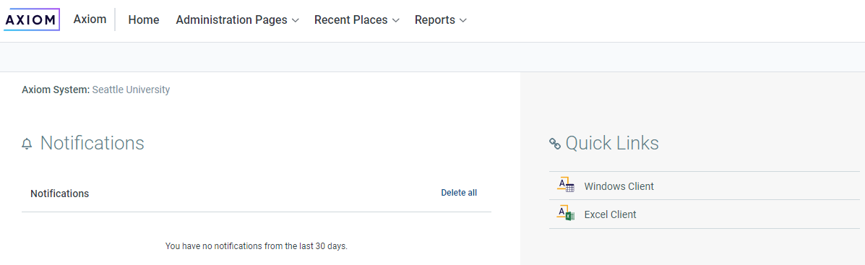
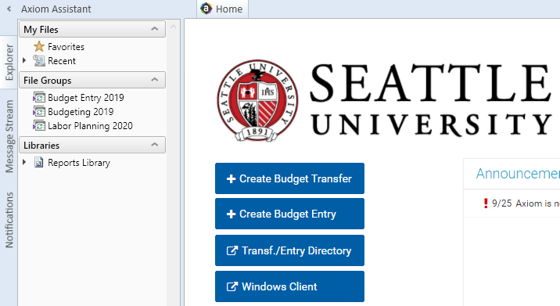
- You will know you are in Windows Client because there will be tabs running along the left-hand side of the Landing page in the Axiom Assistant

- You can also access Windows Client by clicking the Square with Dots in the top right corner.
