Mobile Check In for Telehealth Visit

- Go to the Home page on the patient portal

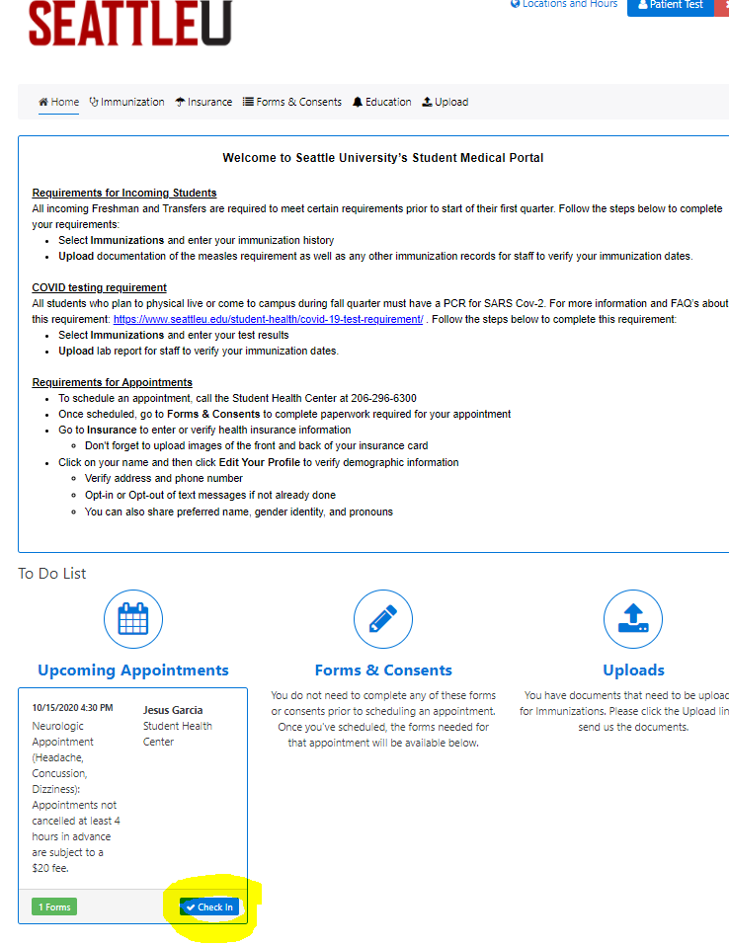
- To check in, click on “Check in”

- If there are forms to complete, this box will pop up letting you know. Complete any forms that were made available with check in or were still needing to be completed
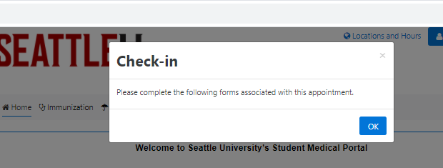
You can not finish check in until these forms are complete

- After you click “OK” it will take you to the list of forms still needing to be completed. Some of these forms you had access to prior to starting the check in process but some of the screens do not populate until you’re checking in. Do not leave this page until you have finished all the forms or you may lose access to some of the required screens.
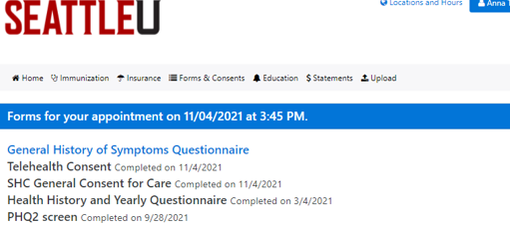
You cannot finish check in until these forms are complete.

- Once Check-in is complete log into your telehealth appointment log in should be available
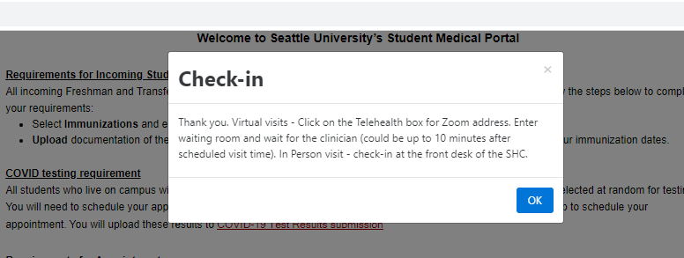

- For Zoom meeting information for your Telehealth appointment go back to Home and click on “Telehealth”
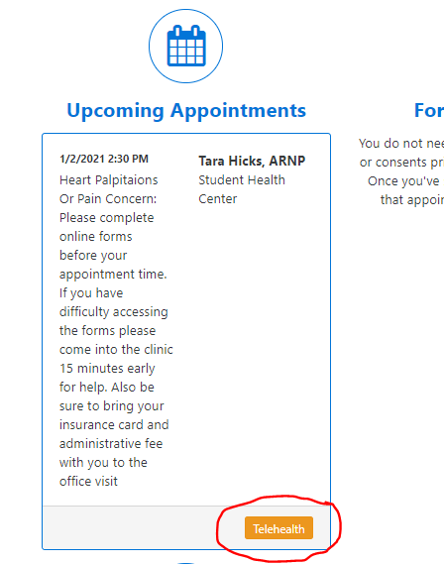
- Click on the Zoom link to get into the waiting room for your appointment. You will be in the waiting room until admitted by your provider. If paperwork isn’t completed or you arrive late your appointment will likely need to be rescheduled.
