**Rain Gardens of SU: Lemieux Library & McGoldrick Learning Commons**

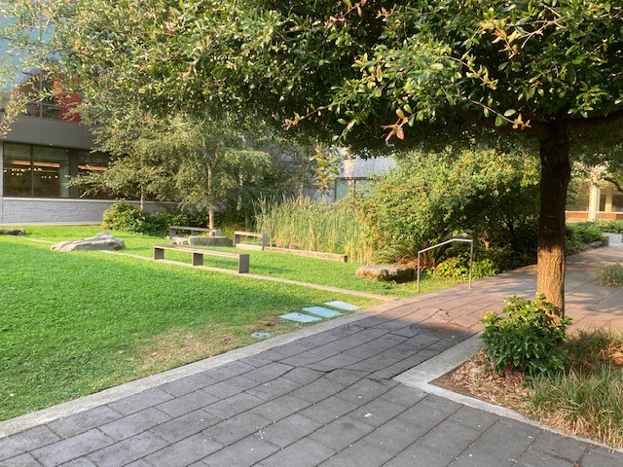

The McGoldrick Learning Commons addition, the plaza, Columbia St. and the lower mall (11th Ave.) all contribute water to the lower rain garden. Grates in the hard surface of the plaza directly send water into the rain garden. The lower rain garden is about 2,100 sq ft and has a volume of about 20,000 gallons of freeboard (not including the capacity of the soil). A 10,000 gallon cistern fills, filters, and holds water from the Commons addition roof before releasing it into the lower rain garden.

The rain gardens can handle approximately 1.7” of water over the entire site in a 24 hour period of time without overflowing any water into the city storm drains.  This is approximately 100,000 gallons of water managed on site for any given storm event. The system was designed to handle a 25 year storm event.

The “water wall” feature uses 100% rain water. The cistern behind the wall is about 2,500 gallons with a cartridge filter and an ultraviolet light for water purification. The granite face used for the water wall is repurposed from the old lobby of the Lemieux Library building.

The original building discharges water into two rain gardens on either side of the west entrance.

The west side rain gardens are lined because of historic issues with water intrusion into the library basement. This is a closed system, running from south to north into a HDP-lined swale with a 3ft deep soil/gravel mix.

Total volume of the all rain gardens and swales (west side swales, north side swale, cistern, and lower rain gardens) is about 25,000 gallons.

The Commons addition roof is approximately 11,000 sq ft, the original library roof is about 18,000sq ft, so the annual run-off for these two structures is approximately 678,600 gallons.

A little over two million gallons of water falls on the site in an average year.

The project site is a little more than two acres.

