Rain Gardens of SU: Union Green Wildlife Garden

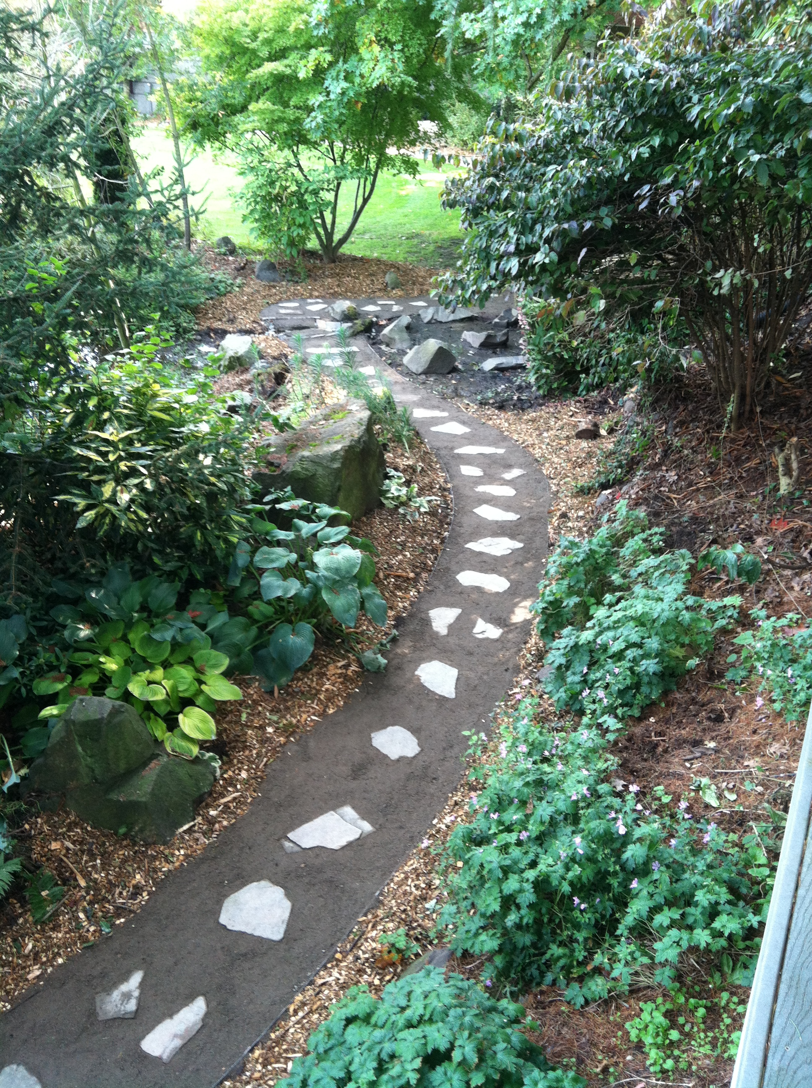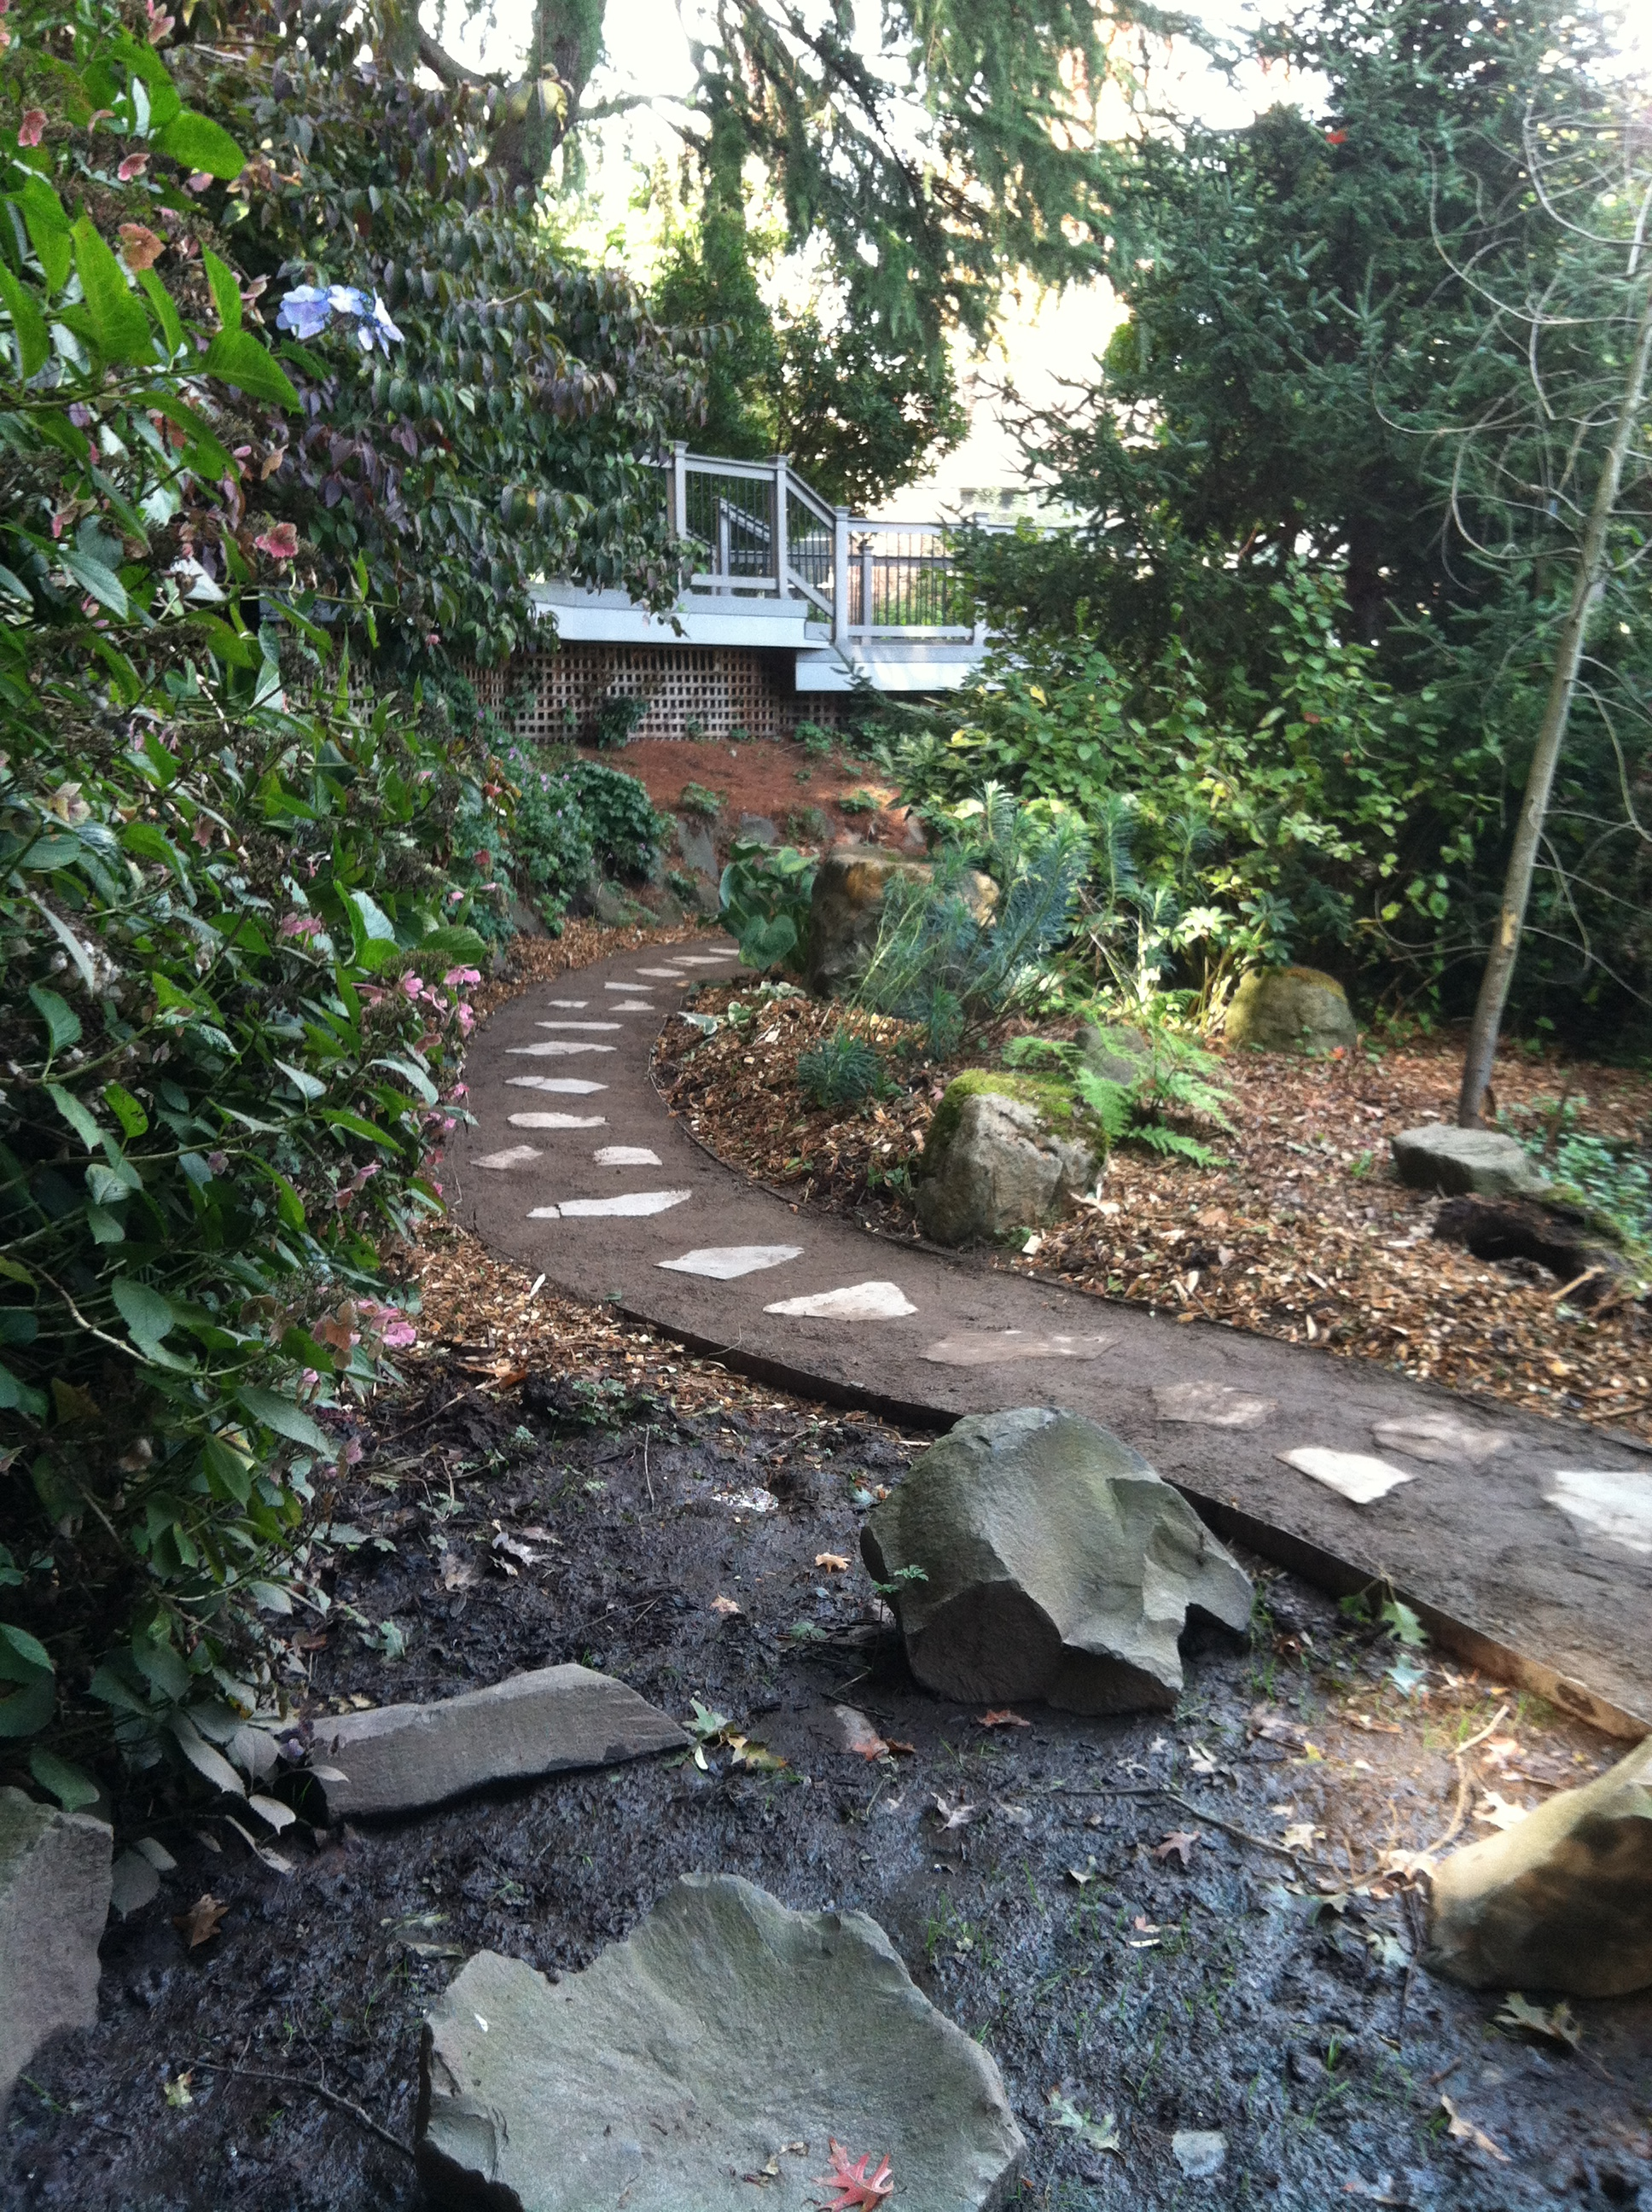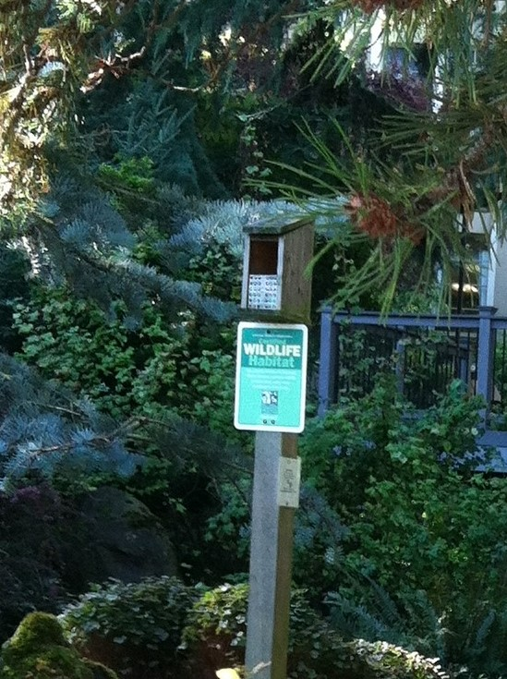

The ‘wildlife garden’ is a shallow depression rain garden that receives runoff from storm water and irrigation across paved surfaces nearby.
Rain gardens slow down the rush of water from paved areas, hold the water for a short period of time allowing it to infiltrate into the ground.
The garden has been planted with deep rooting native plants and grasses.
Native plantings in the garden are habitat and attract many types of birds, butterflies, native bees, mud daubers and also squirrels and racoons.

