Rain Gardens of SU: Advancement and Alumni

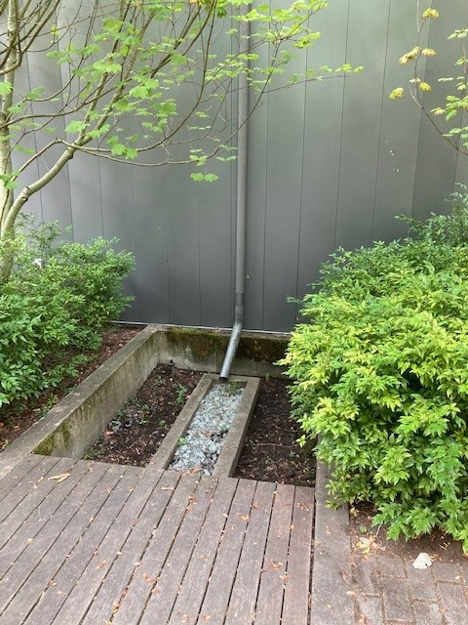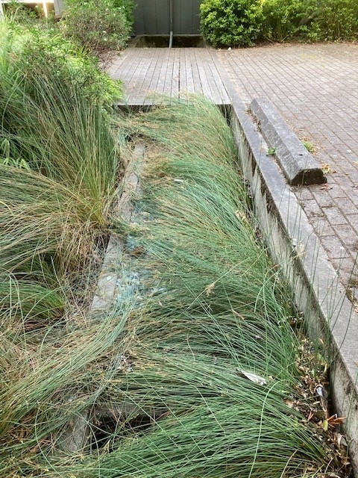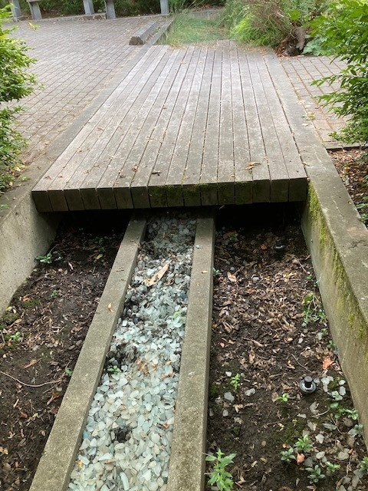

The rain garden is planted with native rushes collects and briefly detains rainwater from the buildings roof and the courtyard paving. Rainwater is eventually released into the underground cistern where it is stored to supply a portion of the irrigation water.

Native and drought tolerant landscaping uses water efficient drip irrigation. Permeable pavers allow rainwater rain water to return directly to the soil.

