10/2017
Soldering Iron
- Soldering tools can cause severe burns when used improperly. The heating element is commonly above 400°C/700°F!
- Use clamping devices to hold the work or components in place. This is more secure than using one of your hands and leaves both hands free to work with the soldering tool. If you must hold a component or wire, hold it with tweezers or clamps to prevent an accidental skin burn.
- Never leave hot soldering tools unattended. Stay with the soldering tool for 5 minutes until it has cooled to a safe temperature.
Solder Smoke Absorber
- Solder smoke is toxic to the body, always use the smoke absorber.
- The placement of the smoke absorber is important. Place the smoke absorber as close as possible and no more than 1-2 inches away from your project so that it pulls the fumes into the filter system.
- Open a window to allow better ventilation.
Eye Protection
- Wear eye protection. Solder can splatter a short distance.
Wash Hands
- Always wash your hands with soap and water after soldering.
Soldering Training
- Be sure you are trained to use the soldering tools before proceeding.
- Online Guides: http://www.circuitrework.com/guides/guides.shtm
- Video Guides: https://www.seattleu.edu/scieng/ece/student-resources/laboratory-resources/howtosolder/
- Check with the teacher’s assistance or laboratory manager for guidance and a short lesson.
- See the laboratory manager for old project boards that you can use to develop your skills before soldering your project board.

10/2017
Soldering Iron
- Soldering tools can cause severe burns when used improperly. The heating element is commonly above 400°C/700°F!
- Use clamping devices to hold the work or components in place. This is more secure than using one of your hands and leaves both hands free to work with the soldering tool. If you must hold a component or wire, hold it with tweezers or clamps to prevent an accidental skin burn.
- Never leave hot soldering tools unattended. Stay with the soldering tool for 5 minutes until it has cooled to a safe temperature.
Solder Smoke Absorber
- Solder smoke is toxic to the body, always use the smoke absorber.
- The placement of the smoke absorber is important. Place the smoke absorber as close as possible and no more than 1-2 inches away from your project so that it pulls the fumes into the filter system.
- Open a window to allow better ventilation.
Eye Protection
- Wear eye protection. Solder can splatter a short distance.
Wash Hands
- Always wash your hands with soap and water after soldering.
Soldering Training
- Be sure you are trained to use the soldering tools before proceeding.
- Online Guides: http://www.circuitrework.com/guides/guides.shtm
- Video Guides: https://www.seattleu.edu/scieng/ece/student-resources/laboratory-resources/howtosolder/
- Check with the teacher’s assistance or laboratory manager for guidance and a short lesson.
- See the laboratory manager for old project boards that you can use to develop your skills before soldering your project board.
10/2017
Read the following soldering safety information before starting work. This information should be readily accessible from the soldering station.
Soldering tools can cause severe burns when used improperly.
Soldering Iron
- Never touch the heating element of the soldering iron. It is commonly above 400°C/700°F!
- Always return the soldering iron to the stand. Never put it down on your workbench even for a moment.
- Use clamping devices to hold the work or components in place. This is more secure than using one of your hands and leaves both hands free to work with the soldering tool. If you must hold a component or wire, hold it with tweezers or clamps to prevent an accidental skin burn.
- Allow solder joints a minute or so to cool down before you touch them.
- Before changing a solder tip be sure the soldering station is turned off and has cooled down for 5 minutes to a safe temperature.
- Never leave hot soldering tools unattended. Stay with the soldering tool for 5 minutes until it has cooled to a safe temperature.
- Keep the soldering area clean and clutter-free to prevent damage or burning from the heated iron.
- Paper and other combustible materials should not be place near the soldering tools.
Solder Smoke Absorber
- Always use a smoke absorber. Solder smoke is toxic to the body. Do not solder unless the smoke absorber is functioning properly and report any issue immediately - fernandg@seattleu.edu.
- The placement of the smoke absorber is important. Place the smoke absorber as close to your project as possible so that it pulls the fumes into the filter system.
- Open a window to allow better ventilation.
- The department must keep a record of the filter changes. Use only a HEPA+Carbon filters. Annually test for proper function.
Eye Protection
- Wear eye protection. Solder can splatter a short distance.
Soldering Training
- Be sure you are trained to use the soldering tools before proceeding.
- Online Guides: http://www.circuitrework.com/guides/guides.shtm
- Video Guides: https://www.seattleu.edu/scieng/ece/student-resources/laboratory-resources/howtosolder/
- Check with the teacher’s assistance or laboratory manager for guidance and a short lesson.
- See the laboratory manager for old project boards that you can use to develop your skills before soldering your project board.
Wash Hands
- Always wash your hands with soap and water after soldering.
Pay Attention and Be Aware of Your Surroundings
- Be careful of what you do, work with caution. Don't use the soldering tool if you are not concentrating on your work.
- Don’t use soldering tools in a busy area where other students may not be aware of the danger.
Avoid Unexpected Operation and Skin Burns
- Make sure that the soldering iron’s power switch is turned off before inserting the power plug into the wall socket.
- Another student may have used the soldering station prior to you so be cautions before handling.
Electrical Safety
- Do not use a soldering iron that has damage to the body, cable, or cord. Report any issue immediately - fernandg@seattleu.edu .

FRONT SIDE
MAINTENANCE INFORMATION
Air Filters
Use a combined HEPA Merv13 filter plus charcoal filter. See specifications below.
Sources of HEPA media: https://www.airfilterusa.com/order-custom-air-filter then select INDUSTRIAL>INSERTS> and see below for the specifications used:
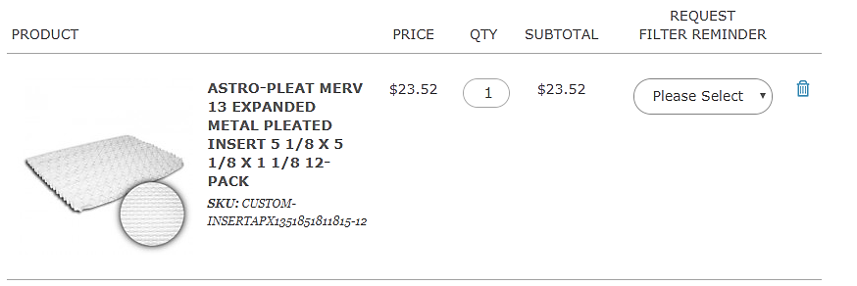
Sources of carbon media: https://www.airfilterusa.com/order-custom-air-filter then select INDUSTRIAL>PADS>CARBON PAD> and see below for the specifications used: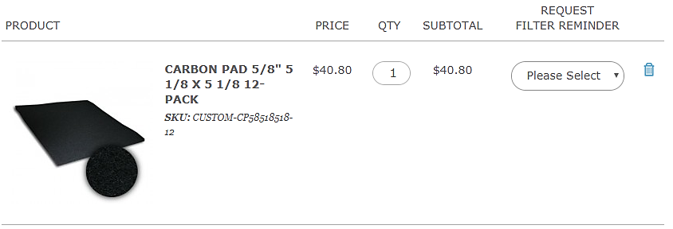

FILTER CHANGE DATE _________________ FILTER CHANGE DATE _________________

FILTER CHANGE DATE _________________ FILTER CHANGE DATE _________________

FILTER CHANGE DATE _________________ FILTER CHANGE DATE _________________

FILTER CHANGE DATE _________________ FILTER CHANGE DATE _________________

FILTER CHANGE DATE _________________ FILTER CHANGE DATE _________________

BACK SIDE

