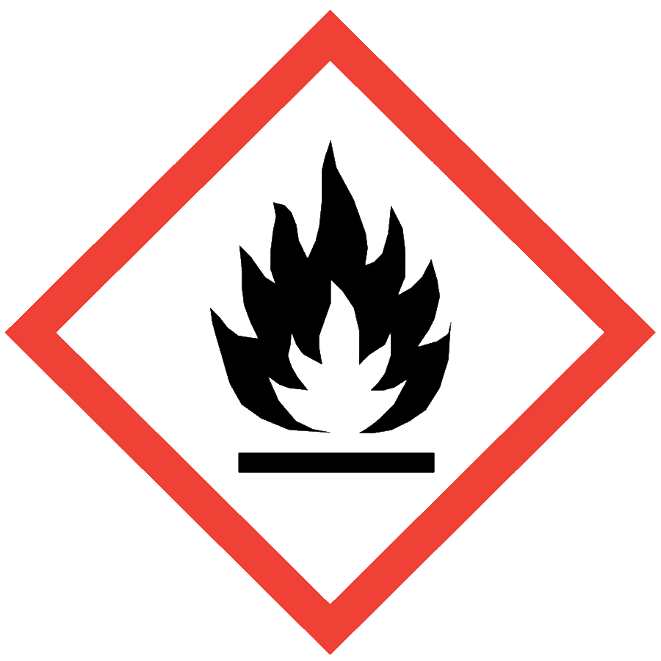
PYROPHORICS
Pyrophoric chemicals are characterized by auto-ignition temperatures below 130 °F (54 °C). These chemicals can spontaneously ignite when exposed to air or water and therefore must be handled in an inert atmosphere by trained personnel. Examples of common pyrophoric chemicals include organolithium reagents, metal hydrides and aluminum alkyl compounds.
This document describes generally applicable controls for pyrophoric materials. Users are strongly encouraged to develop chemical-specific SOPs for pyrophoric materials before working with them.

ENGINEERING/VENTILATION CONTROLS
- Glovebox—required for pyrophoric solids; strongly recommended for pyrophoric liquids
- A Schlenk line inside a chemical fume hood may be used for pyrophoric liquids
- Gas cabinet for pyrophoric gases
Handling and storage areas must be equipped with automatic sprinklers.

SAFE WORK PRACTICES
- Follow universal administrative controls described in the Chemical Hygiene Plan.
- Laboratory-specific training, including hands-on instruction, must be completed and documented before individuals can use pyrophoric chemicals.
- Purchase only the minimum amount of pyrophoric material needed and dispose of excess material when planned experiments are completed.
- Use a buddy system when working with pyrophoric materials: schedule the work to ensure that someone familiar with the hazards is nearby to respond in an emergency.
- Remove unnecessary items and flammable or combustible materials from the work area before beginning work with pyrophoric chemicals.
- Verify that an appropriate fire extinguisher is readily available before beginning work. Contact the ASO for assistance identifying an appropriate fire extinguisher.
- Inspect any air-free seal on containers with highly reactive and unstable chemicals. If damaged, contact EHS for removal and disposal.
- Handle pyrophoric solids only in an inert atmosphere glovebox or glove bag.
- When transferring pyrophoric liquids,
  - Use syringes that have Luer lock fittings or use cannula transfer techniques.
  - Do not exceed 60% of the syringe capacity.
- When handling pyrophoric liquids in a chemical fume hood,
  - Limit syringe transfers to 10 mL.
  - Perform manipulations over a spill tray.
  - Keep the sash as low as possible.
  - Use a blast shield.

PPE
- Eye Protection: ANSI Z87.1 safety goggles
- Body Protection: Nomex lab coat or equivalent; choose snaps over buttons for rapid removal
- Hand Protection: protective gloves appropriate for the chemical being used (consult the SDS); consider the likelihood of fire when selecting hand protection—chloroprene (Neoprene), for example, resists burning
Wear non-synthetic street clothing under PPE when working with pyrophoric materials.
Depending on the risk assessment, a face shield and/or a chemical-resistant splash apron may be needed. Additional PPE may be required if the chemical has additional hazard classification(s).

HANDLING AND STORAGE
- Keep containers closed when not in use.
- Ensure that containers are in good condition and compatible with the material.
- Store pyrophoric liquids in sealed containers with PTFE-lined septa to prevent air exposure.
- Store pyrophoric gases in an appropriate gas cabinet.
- Never return unused quantities back to the original container.
- Refrigerators and freezers storing pyrophorics must be designed to store flammable liquids and meet the requirements for Class I, Division I Electrical Safety Code (NFPA 45 and 70).
- Store pyrophoric materials in a secondary container away from incompatible materials.
- Wash hands thoroughly after handling.
- Consult Sections 7 and 10 the SDS for chemical-specific incompatibilities and storage recommendations.

SPILL AND ACCIDENT PROCEDURE
Consult the Chemical Hygiene Plan for general spill and accident procedures.
If pyrophoric materials spill in a glovebox, quench the spilled material slowly with isopropanol. Absorb with a non-combustible absorbent (e.g., powdered lime, sand) and dispose as hazardous waste.
If pyrophoric materials spill outside of a glove box, an appropriate fire extinguisher may be used to extinguish a small fire. For a large fire, evacuate the area and activate the building fire alarm.

WASTE DISPOSAL
Pyrophoric materials can be disposed of through Seattle University’s Hazardous Waste Program. As long as the chemical receptacle can safely contain the chemical for transport, there is no need to quench any unused pyrophoric material before submitting it for disposal.
Disposal of Pyrophoric Reagents: Although pyrophoric reagents can be disposed of through the Hazardous Waste Program, it is often necessary to quench unused pyrophoric materials using careful hydrolysis. Quenching is only performed by faculty or staff and not by undergraduate students.
Unused pyrophoric materials must be quenched under inert atmosphere with adequate cooling by slowly adding first isopropanol, then methanol, then water. Once the quench is completed and there are no signs of further reaction, dispose of the quench mixture as hazardous chemical waste. Detailed quenching protocols must be covered and documented as lab-specific training for anyone working with pyrophoric materials.
Note: Aqueous base reacts with metals, particularly aluminum, so do not use metal cans to contain the quenching waste.

ADDITIONAL INFORMATION
Sigma-Aldrich bulletin on handling air-sensitive reagents
Sigma-Aldrich bulletin on handling pyrophoric reagents

