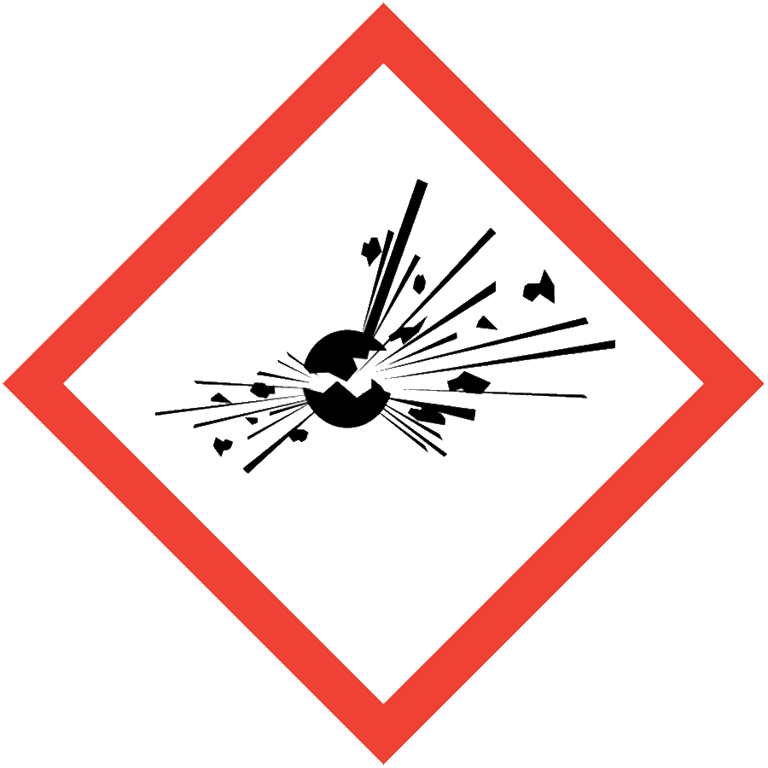
POTENTIALLY EXPLOSIVE CHEMICALS
Potentially explosive chemicals (PECs) are liquid or solid materials that can undergo a sudden release of pressure, gas and heat when subjected to an initiating mechanism such as friction, impact, catalysts, heat or light. Examples include nitrocellulose, dibenzoyl peroxide, picrate salts and most “trinitro-” compounds.
Note: The SOP Library contains separate SOPs for picric acid and peroxide-forming chemicals, which are not covered here.

ENGINEERING/VENTILATION CONTROLS
- Chemical fume hood
- Blast shield
Choose equipment that cannot generate static electricity or sparks if possible.

SAFE WORK PRACTICES
- Follow universal administrative controls described in the Chemical Hygiene Plan.
- Laboratory-specific training, including hands-on instruction, must be completed and documented before individuals can use PECs.
- Purchase only the minimum amount of PEC needed and dispose of excess material when planned experiments are completed.
- Use a buddy system when working with PECs: schedule the work to ensure that someone familiar with the hazards is nearby to respond in an emergency.
- Prepare an experiment plan that describes the safety considerations for each step of the experiment, including safe disposal (i.e., cradle to grave), before beginning work.
- Keep the fume hood sash at the lowest practical height while working and close the sash when the fume hood is not in use.
- Wash hands thoroughly after handling PECs.
Limits on Scale: The PI/supervisor must communicate and enforce clear limits on the quantity of each PEC that can be used in any single experiment. Consult with your PI if you do not know the quantity limit(s) for your lab.
Initiating Mechanism: Before working with any PEC, consult the SDS to determine the initiating mechanism that could lead to an explosion, i.e., friction, impact, catalysts, light or heat.

PPE
- Eye Protection: ANSI Z87.1 safety glasses or goggles
- Body Protection: lab coat
- Hand Protection: protective gloves appropriate for the chemical being used (consult the SDS)
Depending on the risk assessment, a face shield may be appropriate. Additional PPE may be required if the chemical has additional hazard classification(s).

HANDLING AND STORAGE
- Store PECs following the manufacturer’s recommendations.
- Keep away from heat, light and any potential initiating mechanisms.
- Label storage enclosures with hazard warnings.
- Minimize quantities in storage and use.

SPILL AND ACCIDENT PROCEDURE
Consult the Chemical Hygiene Plan for spill and accident procedures.

DECONTAMINATION AND WASTE DISPOSAL
- Decontaminate work areas, fume hoods/gloveboxes and equipment while wearing proper PPE. Consult the SDS for decontamination procedures.
- Collect PECs in chemically compatible sealed containers protected from light and heat.
- Segregate PEC waste from other waste materials.
- Label waste containers with a Seattle University Hazardous Waste Label.
- Consult the Regulated Waste Management policy for more details on waste disposal. Specific disposal recommendations are available in the SDS.

