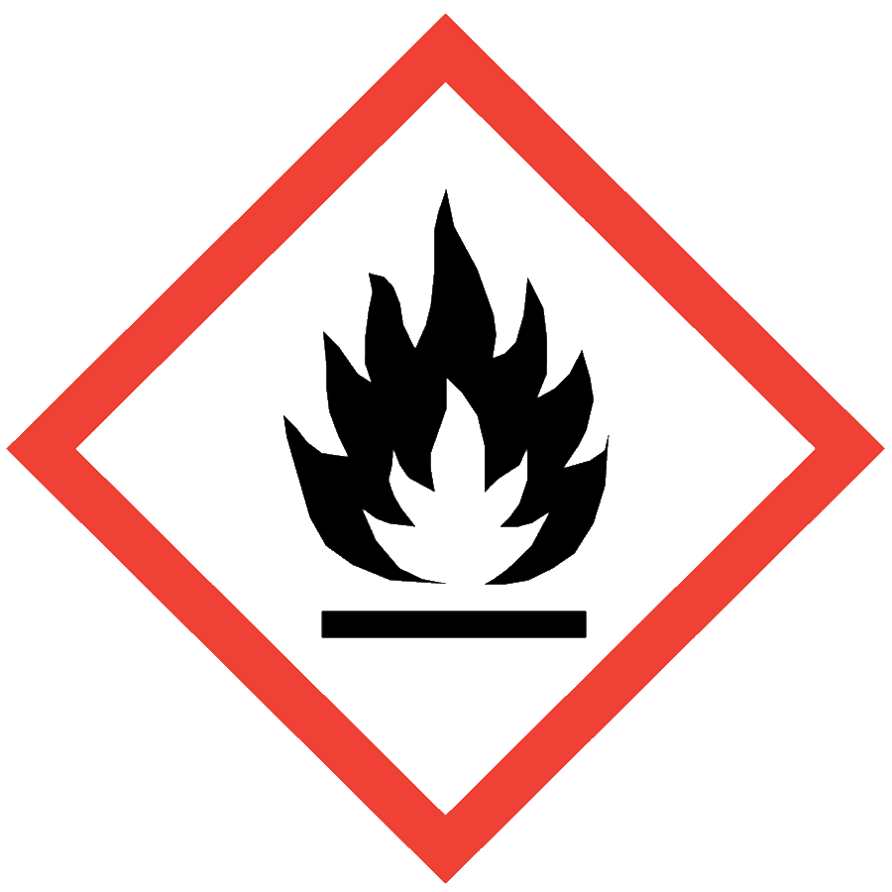
PEROXIDE-FORMING CHEMICALS
Peroxide-forming chemicals (PFCs) are organic compounds that may form potentially explosive organic peroxides through exposure to air over time. Many of these chemicals are common solvents, and care must be taken to prevent the formation of peroxides. A common practice is the addition of stabilizers (e.g., hydroquinone and BHT) that inhibit the chain reaction of peroxide formation; however, these stabilizers can be consumed and do not guarantee against peroxide formation. Safety data sheets (SDSs) typically note peroxide forming hazards for a material in Section 2.3. There is no hazard symbol specific to PFCs.
There are three classes of PFCs, which have different storage requirements. Specific guidelines for allowable storage time limits of containers based on these classifications are provided in Appendix B of the Chemical Hygiene Plan and reproduced at the end of this document. Extensions on storage time limits may be considered if the lab can demonstrate that the PFCs in question are safe to use. Peroxide detection strips can be obtained from chemical vendors.
Many PFCs are also flammable or combustible liquids. Follow additional precautions in the Flammable and Combustible Liquids SOP when applicable.

ENGINEERING/VENTILATION CONTROLS
Handling PFCs in a fume hood is strongly recommended. At minimum, adequate general laboratory ventilation must be provided to maintain exposure below safe regulatory limits.
Some PFCs are particularly hazardous substances (i.e., carcinogens, acute toxicants and/or reproductive toxicants) and must be worked with in a chemical fume hood.
If Permissible Exposure Limits (PELs) may be exceeded, a chemical fume hood or other engineering control is required. PELs can be found in Section 8 of an SDS.

SAFE WORK PRACTICES
- Know the signs and symptoms of exposure to the material before working with it. (Consult the SDS.)
- Follow universal administrative controls described in the Chemical Hygiene Plan.
- Mark PFCs with the receipt date, opening date and any testing date(s) and result(s).
- Inspect air-free seals on containers with highly reactive and unstable chemicals.
- Whenever possible, purge air from the headspace of a PFC container with inert gas (e.g., nitrogen, argon) to remove oxygen.
- Dispose of PFCs within 18 months of receiving or before any specified expiration date from the manufacturer, whichever is sooner.
- Wash hands thoroughly after handling PFCs.

PPE
- Eye Protection: ANSI Z87.1 safety glasses or goggles
- Body Protection: lab coat
- Hand Protection: protective gloves appropriate for the chemical being used (consult the SDS)
Additional PPE may be required if the chemical has additional hazard classification(s).

HANDLING AND STORAGE
Do not move or disturb a PFC container if there is any sign of peroxide formation such as discoloration, cloudiness, stratification or crystal formation anywhere in or on the bottle. Notify others to avoid the area. Place a Facilities Services work order for immediate disposal.
- Keep containers closed when not in use.
- Ensure containers are in good condition and compatible with the material.
- Store PFCs in airtight containers in a dark, cool and dry place. Avoid refrigeration because it may facilitate crystallization.
- Label PFCs with the receipt date and opening date. Store containers with labels facing forward to minimize handling.
- Use or dispose of PFCs within 3 months of distillation. Distillation results in an uninhibited PFC.
- Use or dispose of PFCs before the manufacturer’s expiration date.
- Consult Sections 7 and 10 of the SDS for chemical-specific storage recommendations.

SPILL AND ACCIDENT PROCEDURE
Do not handle or disturb containers of PFCs if they are old (greater than 2 years old or of unknown age) of if there is any sign of peroxide formation such as discoloration, cloudiness, crystal formation or stratification anywhere in or on the bottle. Place a Facilities Services work order for immediate disposal. Consult the Chemical Hygiene Plan for spill and accident procedures.

DECONTAMINATION AND WASTE DISPOSAL
- Decontaminate work areas, fume hoods/gloveboxes and equipment while wearing proper PPE. Consult the SDS for decontamination procedures. Soap and water are effective for many materials.
- Collect non-expired PFC waste in chemically compatible containers labeled with a Seattle University Hazardous Waste Label.
- Segregate incompatible waste streams (e.g., flammables from oxidizers). Refer to Section 10 of the SDS for specific incompatibilities.
- Consult the Regulated Waste Management policy for more details on waste disposal. Specific disposal recommendations are available in the SDS.

CHEMICAL HYGIENE PLAN APPENDIX B: PEROXIDE-FORMING CHEMICALS

Table 1: Classes of Peroxidizable Chemicals

A. Chemicals that form explosive levels of peroxides without concentration
Butadieneª | Divinylacetylene | Tetrafluoroethyleneª | Vinylidene chloride
Chloropreneª | Isopropyl ether

B. Chemicals that form explosive levels of peroxides on concentration
Acetal | Decahydronaphthalene | 2-Hexanol | 1-Phenylethanol
Acetaldehyde | Diacetylene | Methylacetylene | 2-Phenylethanol
Benzyl alcohol | Dicyclopentadiene | 3-Methyl-1-butanol | 2-Propanol
2-Butanol | Diethyl ether | Methylcyclopentane | Tetrahydrofuran
Cumene | Diethylene glycol dimethyl ether (diglyme) | Methyl isobutyl ketone | Tetrahydronaphthalene
Cyclohexanol | Dioxanes | 4-Methyl-2-pentanol | Vinyl ethers
2-Cyclohexen-1-ol | Ethylene glycol dimethyl ether (glyme) | 2-Pentanol | Other secondary alcohols
Cyclohexene | 4-Heptanol | 4-Penten-1-ol

C. Chemicals that may autopolymerize as a result of peroxide accumulation
Acrylic acid^{b} | Chlorotrifluoroethylene | Vinyl acetate | Vinyladiene chloride
Acrylonitrile^{b} | Methyl methacrylate^{b} | Vinylacetylene
Butadiene^{c} | Styrene | Vinyl chloride
Chloroprene^{c} | Tetrafluoroethylene^{c} | Vinylpyridine

D. Chemicals that may form peroxides but cannot clearly be placed in sections A–C
Acrolein | tert-Butyl methyl ether | Di(1-propynyl) ether^{f} | n-Methylphenetrole
Allyl ether^{d} | n-Butyl phenyl ether | Di(2-propynyl) ether | 2-Methyltetrahydrofuran
Allyl ethyl ether | n-Butyl vinyl ether | Di-n-propoxymethane^{d} | 3-Methoxy-1-butyl acetate
Allyl phenyl ether | Chloroacetaldehyde diethylacetal^{d} | 1,2-Epoxy-3-isopropoxypropane^{d} | 2-Methoxyethanol
p-(n-Amyloxy)benzoyl chloride | 2-Chlorobutadiene | 1,2-Epoxy-3-phenoxypropane | 3-Methoxyethyl acetate
n-Amyl ether | 1-(2-Chloroethoxy)-2-phenoxyethane | p-Ethoxyacetophenone | 2-Methoxyethyl vinyl ether
Benzyl n-butyl ether^{d} | Chloroethylene | 1-(2-Ethoxyethoxy)ethyl acetate | Methoxy-1,3,5,7-cyclooctatetraene
Benzyl ether^{d} | Chloromethyl methyl ether^{e} | 2-Ethoxyethyl acetate | beta-Methoxypropionitrile
Benzyl ethyl ether^{d} | Beta-Chlorophenetole | (2-Ethoxyethyl)-o-benzoyl benzoate | m-Nitrophenetole
Benzyl methyl ether | o-Chlorophenetole | 1-Ethoxynaphthalene | 1-Octene
Benzyl 1-naphthyl ether^{d} | p-Chlorophenetole | O,p-Ethoxyphenyl isocyanate | Oxybis(2-ethyl acetate)
1,2-Bix(2-chloroethoxy)ethane | Cyclooctene^{d} | 1-Ethoxy-2-propyne | Oxybis(2-ethyl benzoate)
Bis(2-ethoxyethyl) ether | Cyclopropyl methyl ether | 3-Ethoxyopropionitrile | beta,beta-Oxydipropionitrile
Bis(2-(methoxyethoxy)ethyl) ether | Diallyl ether^{d} | 2-Ethylacrylaldehyde oxime | 1-Pentene
Bis(2-chloroethyl) ether | p-Di-n-butoxybenzene | 2-Ethylbutanol | Phenoxyacetyl chloride
Bis(2-ethoxyethyl) adipate | 1,2-Dibenzyloxyethane^{d} | Ethyl beta-ethoxypropionate | alpha-phenoxypropionyl chloride
Bis(2-ethoxyethyl) phthalate | p-Dibenzyloxybenzene^{d} | 2-Ethylhexanal | Phenyl o-propyl ether
Bis(2-methoxyethyl) carbonate | 1,2-Dichloroethyl ethyl ether | Ethyl vinyl ether | p-Phenylphenetone
Bis(2-methoxyethyl) ether | 2,4-Dichlorophenetole | Furan | n-Propyl ether
Bis(2-methoxyethyl) phthalate | Diethoxymethane^{d} | 2,5-Hexadiyn-1-ol | n-Propyl isopropyl ether
Bis(2-methoxymethyl) adipate | 2,2-Diethoxypropane | 4,5-Hexadien-2-yn-1-ol | Sodium 8,11,14-eicosatetraenoate
Bis(2-n-butoxyethyl) phthalate | Diethyl ethoxymethylenemalonate | n-Hexyl ether | Sodium ethoxyacetylide^{f}
Bis(2-phenoxyethyl) ether | Diethyl fumarate^{d} | O,p-Iodophenetole | Tetrahydropyran
Bis(4-chlorobutyl) ether | Diethyl acetal^{d} | Isoamyl benzyl ether^{d} | Triethylene glycol diacetate
Bis(chloromethyl) ether^{e} | Diethylketene^{f} | Isoamyl ether^{d} | Triethylene glycol dipropionate
2-Bromomethyl ethyl ether | m,o,p-Diethoxybenzene | Isobutyl vinyl ether | 1,3,3-Trimethoxypropene^{d}
Beta-Bromophenetole | 1,2-Diethoxyethane | Isophorone^{d} | 1,1,2,3-Tetrachloro-1,3-butadiene
o-Bromophenetole | Dimethoxymethane^{d} | beta-Isopropoxypropionitrile^{d} | 4-Vinyl cyclohexene
p-Bromophenetole | 1,1-Dimethoxyethane^{d} | Isopropyl 2,4,5-trichlorophenoxy-acetate | Vinylene carbonate
3-Bromopropyl phenyl ether | Dimethylketene^{f} | Limonene | Vinylidene chloride^{d}
1,2-Butadiyne | 3,3-Dimethoxypropene | 1,5-p-Methadiene
Buten-3-yne | 2,4-Dinitrophenetole | Methyl p-(n-amyloxy)benzoate
tert-Butyl ethyl ether | 1,3-Dioxepane^{d} | 4-Methyl-2-pentanone
ª When stored as a liquid monomer.
^{b} Although these chemicals form peroxides, no explosions involving these monomers have been reported.
^{c} When stored in liquid form, these chemicals form explosive levels of peroxides without concentration. They may also be stored as a gas in gas cylinders. When stored as a gas, these chemicals may autopolymerize as a result of peroxide accumulation.
^{d} These chemicals easily form peroxides and should probably be considered under Part B.
^{e} OSHA-regulated carcinogen.
^{f} Extremely reactive and unstable compound.

Table 2: Safe storage period for peroxide formers
Description | Period
Unopened chemicals from manufacturer | 18 months
Opened containers
Chemicals in Part A, Table 1 | 3 months
Chemicals in Parts B and D, Table 1 | 12 months
Uninhibited chemicals in Part C, Table 1 | 24 hours
Inhibited chemicals in Part C, Table 1 | 12 monthsª
ª Do not store under inert atmosphere
Source: Kelly, RJ. 1996. Chem Health & Safety. 3(5):28.

