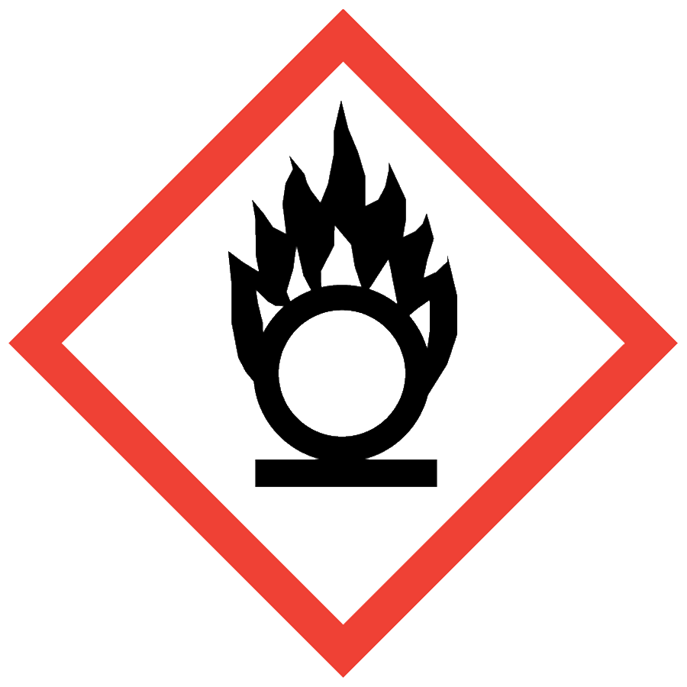
OXIDIZERS

HAZARD CLASS DESCRIPTION
An oxidizer is a chemical that initiates or promotes the combustion of other materials, which can cause fire or release oxygen or other gases. Strong oxidizers can form explosive mixtures when combined with organic or easily oxidized materials. Release of gases can lead to rupture of closed containers.

ENGINEERING/VENTILATION CONTROLS
At minimum adequate general laboratory ventilation must be provided to maintain exposure below safe regulatory limits.
Some oxidizers are particularly hazardous substances (i.e., carcinogens, acute toxicants and/or reproductive toxicants) and must be worked with in a chemical fume hood.
If Permissible Exposure Limits (PELs) may be exceeded, chemical fume hood or other engineering control is required. PELs can be found in Section 8 of an SDS.

SAFE WORK PROCEDURES
- Know the signs and symptoms of exposure to the material before working with it. (Consult the SDS.)
- Follow universal administrative controls described in the Chemical Hygiene Plan.
- Consult a faculty member, lab manager or the Academic Safety Officer before mixing oxidizing agents with flammable or combustible materials.
- Know where to access and how to use a fire extinguisher. Ensure that a fire extinguisher is readily available (within 30 feet) and appropriate (minimum rated 40BC) for the materials in use.
- Wash hands thoroughly after handling oxidizers

PPE
- Eye Protection: ANSI Z87.1 safety glasses or goggles
- Body Protection: lab coat; avoid synthetic fibers and choose a flame-resistant option if there is a risk of fire
- Hand Protection: protective gloves appropriate for the chemical being used (consult the SDS)
Depending on risk assessment, a face shield and/or blast shield may be appropriate. Additional PPE may be required if the chemical has additional hazard classification(s).

HANDLING AND STORAGE
- Keep containers closed when not in use.
- Ensure containers are in good condition and compatible with the material.
- Store away from flammable and combustible materials.
- Consult Sections 7 and 10 of the SDS for chemical-specific storage recommendations.

SPILL AND ACCIDENT PROCEDURE
Consult the Chemical Hygiene Plan for spill and accident procedures.

DECONTAMINATION AND WASTE DISPOSAL
- Decontaminate work areas, fume hoods/gloveboxes and equipment while wearing proper PPE. Consult the SDS for decontamination procedures. Soap and water are effective for many materials.
- Collect waste in chemically compatible containers labeled with a Seattle University Hazardous Waste Label.
- Segregate incompatible waste streams (e.g., flammables and combustibles). Refer to Section 10 of the SDS for specific incompatibilities.
- Consult the Regulated Waste Management policy for more details on waste disposal. Specific disposal recommendations are available in the SDS.

