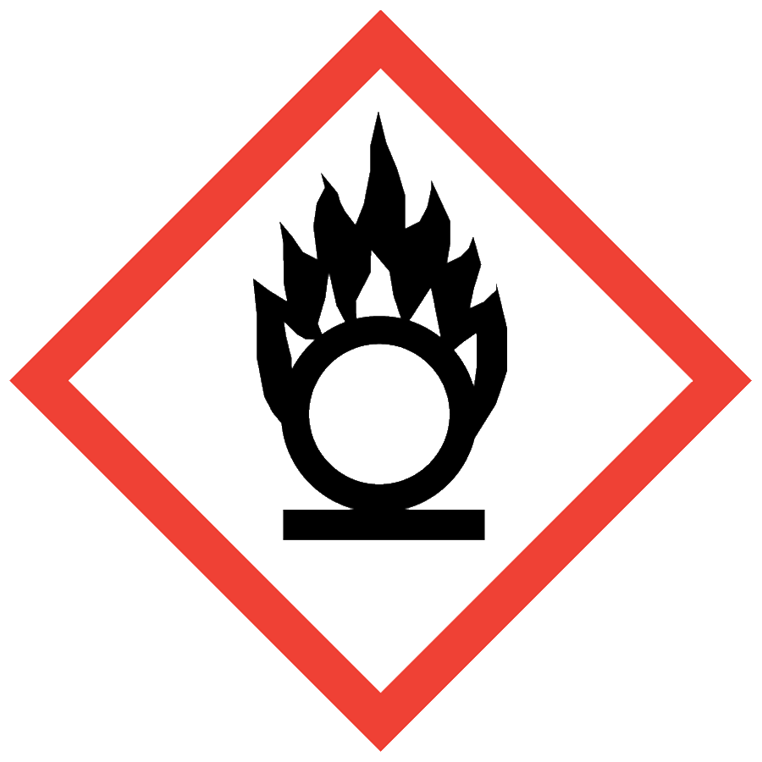
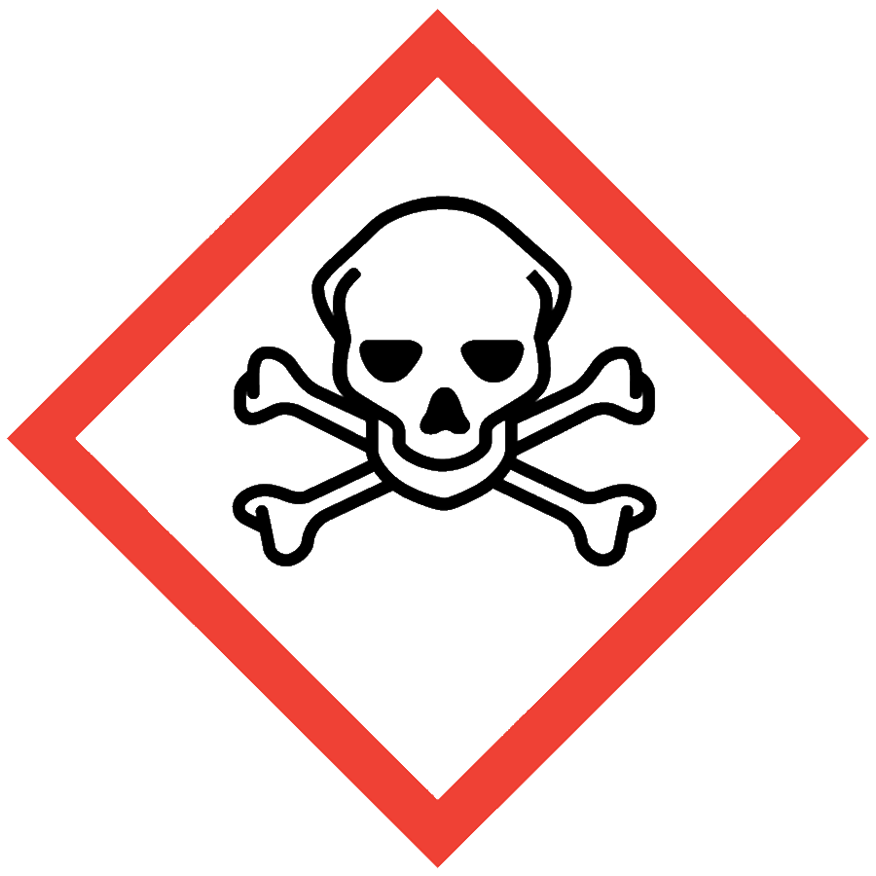
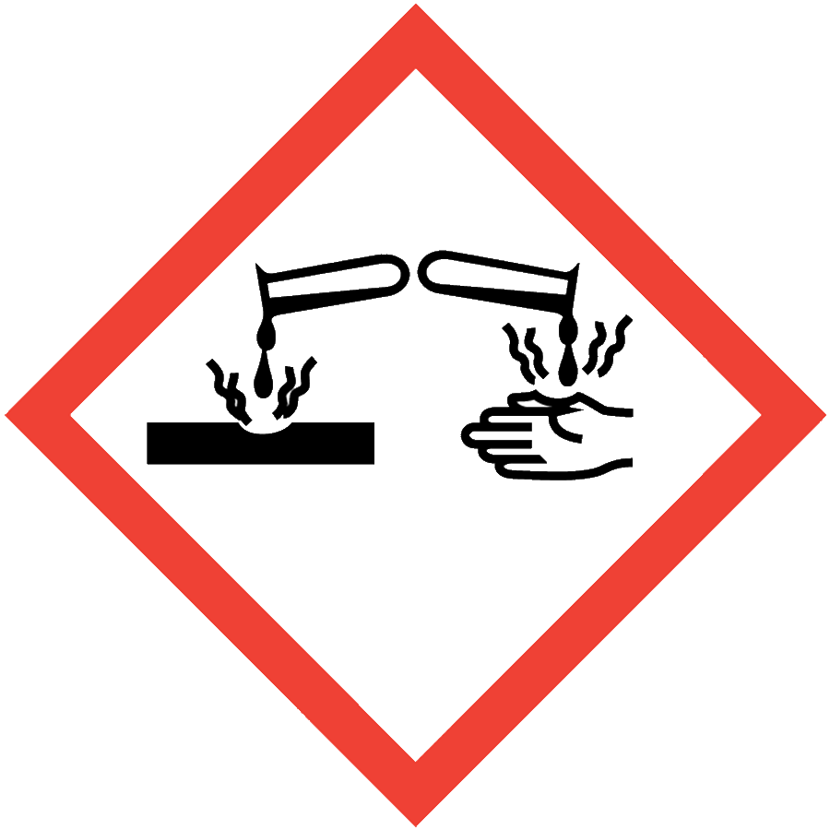
NITRIC ACID
Nitric acid, HNO₃, is a corrosive acid and a strong oxidizer. Nitric acid may be harmful if ingested, inhaled or absorbed through the skin, and it can cause severe skin and eye burns and is extremely destructive to mucous membranes.
If you prepare aqua regia (mixture of HNO₃ and HCl at 1:3 ratio), a separate SOP is required.

ENGINEERING/VENTILATION CONTROLS
- Chemical fume hood
If a process/experiment cannot be performed in a fume hood, contact the ASO for an assessment to determine necessary controls.

SAFE WORK PRACTICES
- Know the signs and symptoms of exposure to the material before working with it. (Consult the SDS.)
- Follow universal administrative controls described in the Chemical Hygiene Plan.
- Avoid all contact with nitric acid.
- When diluting, add nitric acid to water.
- Wash hands thoroughly after handling nitric acid.

PPE
- Eye Protection: ANSI Z87.1 safety goggles
- Body Protection: lab coat
- Hand Protection: protective gloves appropriate for the chemical(s) in use (consult the SDS)
Depending on the risk assessment, a face shield and/or chemical splash apron may be appropriate. Additional PPE may be required if the process has additional hazards associated with it.

HANDLING AND STORAGE
- Keep containers closed when not in use.
- Ensure containers are in good condition and compatible with the material.
- Store in secondary containment, in well-ventilated areas and below eye level.
- Carefully reseal containers (recommended to also use parafilm to prevent fugitive fumes) and store upright to prevent leaks.
- Segregate from flammables, combustibles, reducing agents, all bases, metals, cyanides, organics and organic acids.

SPILL AND ACCIDENT PROCEDURE
Consult the Chemical Hygiene Plan for spill and accident procedures.

DECONTAMINATION AND WASTE DISPOSAL
- Decontaminate work areas, fume hoods/gloveboxes and equipment while wearing proper PPE. Consult the SDS for decontamination procedures. In general,
  - Sodium bicarbonate can be used to neutralize nitric acid contamination
  - Soap and water can be used after neutralization
- Collect waste in chemically compatible containers labeled with a Seattle University Hazardous Waste Label.
- Segregate incompatible waste streams. Refer to Section 10 of the SDS for specific incompatibilities. Nitric acid must never be combined with organic or reducing agent wastes. Given the breadth of chemicals nitric acid can react with, best practice is to collect nitric acid wastes separately from other waste streams.
- Consult the Regulated Waste Management policy for more details on waste disposal. Specific disposal recommendations are available in the SDS.

