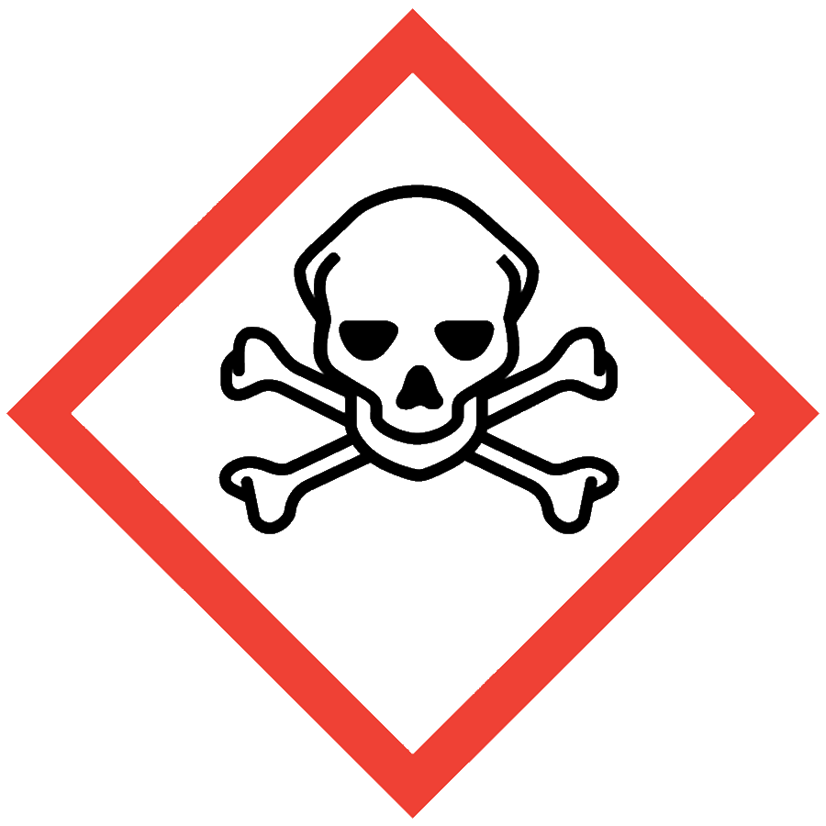
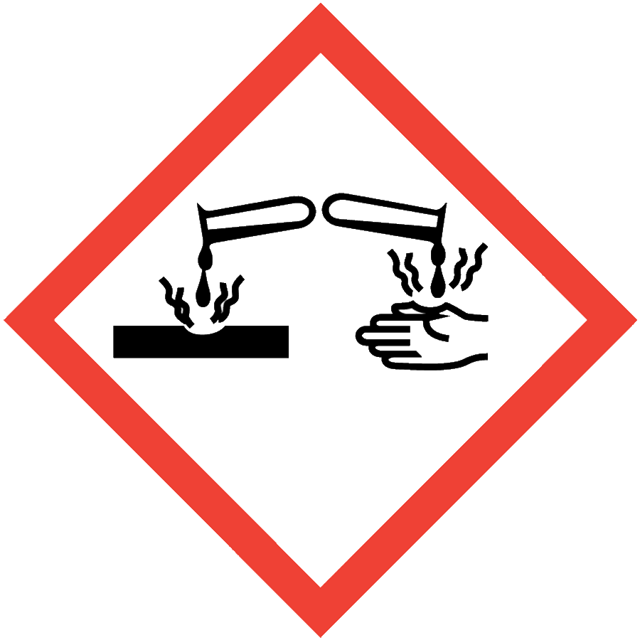
HYDROFLUORIC ACID (HF)
Hydrofluoric acid (HF) is a solution of hydrogen fluoride gas dissolved in water. This mineral acid is highly toxic due to the fluoride ion and can penetrate tissue more rapidly than other mineral acids. HF exposures can occur through contact with the skin or eyes, inhalation or ingestion. HF interferes with nerve function, so symptoms of exposure may not be immediately evident, delaying treatment and increasing the extent and seriousness of injury.
Many chemicals containing fluoride anion, including ammonium bifluoride, tetrabutylammonium fluoride and sodium fluoride, may react with acid or water to produce HF. Carefully review the SDS of fluoride anion-containing compounds for safety precautions that can reduce the formation of HF. If the chemical is being used in a way that could create HF, follow the precautions outlined in this document.

ENGINEERING/VENTILATION CONTROLS
- Chemical fume hood
If a process/experiment cannot be performed in a fume hood, contact the ASO for an assessment to determine necessary controls.

SAFE WORK PRACTICES
- Follow universal administrative controls described in the Chemical Hygiene Plan.
- Laboratory-specific training, including hands-on instruction, must be completed and documented before individuals can work with HF.
- Prepare an experiment plan that describes the safety considerations for each step of the experiment, including safe disposal (i.e., cradle to grave), before beginning work.
- Review emergency procedures and first aid treatment for HF before beginning work.
- Keep 2.5% calcium gluconate gel in an easily accessible location near where HF is used.
- Minimize the amount of HF handled.
- Use HF only in a designated area.
- Avoid contact with HF and exercise particular care when removing gloves.
- Wash hands thoroughly after handling HF.

PPE
- Eye Protection: ANSI Z87.1 safety goggles
- Body Protection: lab coat and natural rubber apron
- Hand Protection: arm-length natural rubber (latex) or chloroprene gloves (consult the SDS for additional information)
Depending on risk assessment, a face shield and/or double gloving may be appropriate. Additional PPE may be required if the process has additional hazards associated with it.

HANDLING AND STORAGE
- HF dissolves glass—store it in its original plastic container.
- Store HF in Nalgene/polypropylene secondary containment.
- Store below eye level in well-ventilated areas.
- Segregate from oxides, organic chemicals, bases and metals.
- Keep containers closed when not in use.
- Label storage area with a hazard warning.
- Minimize quantities in storage and use.
- Consult the SDS for additional chemical-specific storage recommendations.

SPILL AND ACCIDENT PROCEDURE
HF spills are emergencies. Immediately notify others in the area and evacuate the location. Contact Public Safety at 206-296-5911. Do not attempt to clean the spill yourself. Consult the Chemical Hygiene Plan for additional information on emergency spill procedures.
HF exposures are emergencies. See the First Aid Instructions on the next page.

DECONTAMINATION AND WASTE DISPOSAL
- Decontaminate work areas, fume hoods and equipment while wearing proper PPE. Labs handling HF are strongly encouraged to have an HF-specific clean-up kit for decontamination processes.
- Collect HF waste in chemically compatible (polyethylene) containers labeled with a Seattle University Hazardous Waste Label.
- Dispose of empty containers of HF and gloves/PPE that contacted HF as solid hazardous waste.
- Store HF waste in Nalgene/polypropylene secondary containment.
- Consult the Regulated Waste Management policy for more details on waste disposal. Specific disposal recommendations are available in the SDS.

HYDROFLUORIC ACID FIRST AID INSTRUCTIONS
POST THESE FIRST AID INSTRUCTIONS IN THE ROOM(S) WHERE HYDROFLUORIC ACID IS STORED OR HANDLED.
Location of Calcium Gluconate gel (complete this section before posting)
Building and Room:
Exact Location in Room:

BACKGROUND ON HF
Hydrofluoric acid (HF) exposure is very toxic and can be fatal if not treated immediately. HF is absorbed quickly; however, damage/symptoms can occur hours to days later. Any person exposed to HF must have immediate first aid, followed by immediate medical treatment from a physician. When seeking medical attention take a copy of the HF Safety Data Sheet to the Emergency Room.
SKIN EXPOSURE | EYE EXPOSURE
- Immediately flush the affected area with water for 15 minutes at emergency shower or other water source. Remove all contaminated clothing while flushing with water.  - After flushing, apply 2.5% Calcium Gluconate gel to the burn site using a clean, gloved hand. Continue massaging gel into the affected area. Reapply every 15 minutes until emergency medical assistance arrives.  - Get immediate medical assistance:  call 206-296-5911. | - Immediately flush eyes with water for at least 15 minutes at emergency eyewash or other water source. If only one eye is affected, avoid flushing contaminated water into the other eye. If possible, provide continuous irrigation during transport.  - Do not apply Calcium Gluconate gel to eyes.  - Get immediate medical assistance:  call 206-296-5911.
INHALATION | INGESTION
- Move person to fresh air  - Get immediate medical assistance:  call 206-296-5911. | - Do not induce vomiting.  - Rinse mouth with cold water.  - If the victim is conscious, have them drink lots of water to dilute the acid.  - Get immediate medical assistance:  call 206-296-5911.

