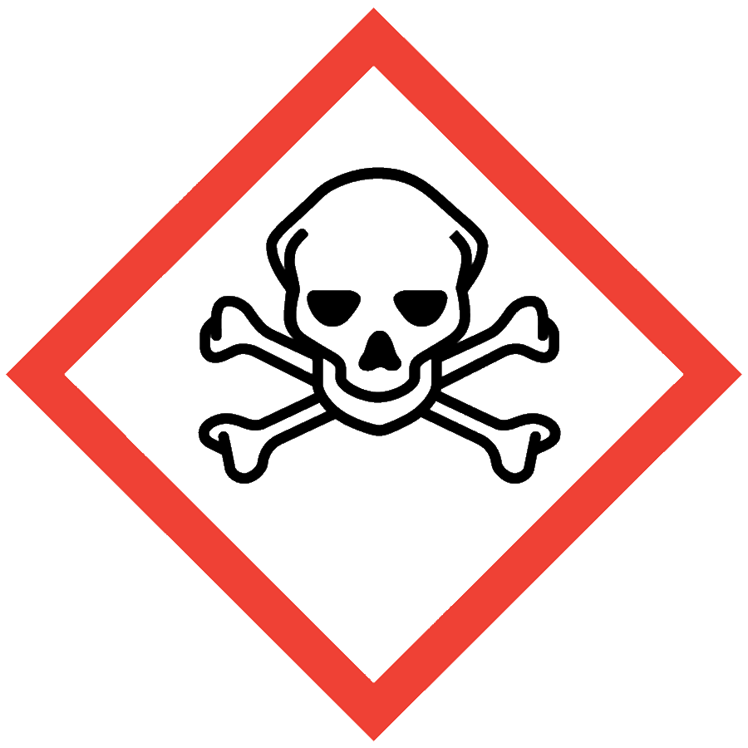
ACUTE TOXICANTS
Acute toxicants are substances that may be fatal or cause damage to target organs as the result of a single exposure or exposures of short duration. These chemicals, associated waste and storage containers must be handled with care to prevent cross contamination of work areas and unexpected contact. Acute toxicants have the following reported median lethal doses (LD₅₀) or median lethal concentrations (LC₅₀):
- Oral LD₅₀ ≤50 mg/kg in rats
- Dermal LD₅₀ ≤200 mg/kg in rabbits
- Inhalation LC₅₀ ≤500 ppm (gas), ≤2 mg/L (vapor) or ≤0.5 mg/L (mist, fume or dust) when administered for 4 hours to rats
Toxicological information is available in Section 11 of a material’s safety data sheet (SDS).

ENGINEERING CONTROLS
- Chemical fume hood or glovebox
If the process/experiment cannot be performed in a fume hood or glovebox, contact the ASO for an assessment to determine necessary controls.

SAFE WORK PRACTICES
- Before beginning work, prepare an experiment plan that describes the safety considerations for each step of the process, including disposal (i.e., cradle to grave).
- Know the signs and symptoms of exposure to the material before working with it. (Consult the SDS.)
- Follow universal administrative controls described in the Chemical Hygiene Plan.
- Limit the amount of material handled: use the smallest amount possible.
- Work with acute toxicants in a designated area.
- Wash hands thoroughly after handling acutely toxic substances.

PPE
- Eye Protection: ANSI Z87.1 safety glasses or goggles
- Body Protection: lab coat
- Hand Protection: protective gloves appropriate for the chemical being used (consult the SDS)
Depending on the risk assessment, a face shield and/or chemical splash apron may be appropriate. Additional PPE may be required if the chemical has additional hazard classification(s).

HANDLING AND STORAGE
- Keep containers closed when not in use.
- Ensure containers are in good condition and compatible with the material.
- Store acute toxicants in secondary containers.
- Work with open containers only in the fume hood or glovebox.
  - Use ventilated containment to weigh solid chemicals or use the “tare” method: weigh an empty container, add the chemical to the container in the fume hood, seal the container, remove it from the fume hood and re-weigh it.
- Label the storage location with a hazard warning.
- Avoid all contact with acute toxicants, including skin contact and inhalation
- Consult Sections 7 and 10 of the SDS for chemical-specific storage recommendations.

SPILL AND ACCIDENT PROCEDURE
Consult the Chemical Hygiene Plan for spill and accident procedures.

DECONTAMINATION AND WASTE DISPOSAL
- Decontaminate work areas, fume hoods/gloveboxes and equipment after each use while wearing proper PPE. Consult the SDS for decontamination procedures. Soap and water are effective for many materials.
- Collect waste in chemically compatible containers labeled with a Seattle University Hazardous Waste Label.
- Segregate incompatible waste streams. Refer to Section 10 of the SDS for specific incompatibilities.
- Consult the Regulated Waste Management policy for more details on waste disposal. Specific disposal recommendations are available in the SDS.

