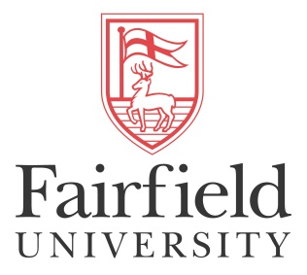
School of Engineering
1073 N Benson Rd.
Fairfield, CT 06824
(203)254-4147

Fairfield University, School of Engineering

Nicaragua Study Abroad Program

Summary: The School of Engineering and the Office of Study Abroad at Fairfield University have partnered with the Universidad Centro Americana (UCA) in Managua, Nicaragua to create an engineering study abroad as an integrated part of the curriculum for all School of Engineering majors in the Fall semester of the sophomore year.
Location: UCA is located in Managua, the capital of Nicaragua. UCA provides a coordinator on site with extensive experience arranging travel and board for visiting and exchange students from the United States. UCA is a Jesuit University, with approximately 10000 students, 2500 in engineering.
Curriculum: Engineering students participating in the program will be placed abroad at UCA for a semester to participate in prescribed curriculum. This facilitates a cohort experience focused and planned around the engineering students and curriculum. UCA will offer a selection of engineering oriented courses for sophomores, with language of instruction in English. Those courses will include Calculus III, Inorganic Chemistry I, Electric Circuits Statics, Data Structures, and Materials Science. All courses have been articulated by Fairfield University and conform to progressions standards for the School of Engineering. Based on their area of specialization, Students will choose 4 courses from the cohort curriculum list. They will also take a Modern History of Nicaragua course that would immerse them in the history, culture and language of the region. Students may also elect to enroll in an intensive 2-week Spanish language course preparatory to the start of the Fall term. All students participating in the program will receive a Fairfield University transcript reflecting earned credits and grades.
Cohort Experience: UCA is able to accommodate a cohort of up to 15 students each Fall. Selection of participants is competitive and nominations of dynamic candidates is encouraged. In country, they will participate in immersion programs to acquaint them with their host country and its people. Courses will be taught in English, but will be integrated with local UCA students as well to build cross-cultural interaction. During the course of the program they will strengthen their Engineering exposure through planned site visits to local industry, guest speakers from industry in the region, and a community based engineering project executed in conjunction with local students and overseen by UCA Engineering Faculty and Community leaders.
Costs: $15,000 inclusive of all coursework, excursions, events, activities, housing, and most meals.
Contacts: For more information, please contact: Associate Dean Ryan Munden, SOE (rmunden@fairfield.edu); Jennifer Ewald, Director, Study Abroad (jewald@fairfield.edu).

