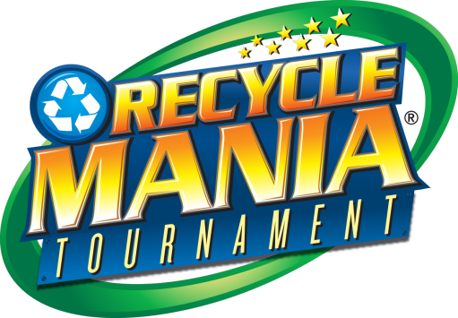
News Release

Seattle University Facilities

Release Date: May, 7 2019 | Contact: Nathan Wolk | Work: (206) 296-6459
Internet: www.seattleu.edu/recyclemania | Email: wolknathanie@seattleu.edu

Seattle University Comes in 20th Nationwide

Seattle, WA –Seattle University competed in the 2019 Recyclemania Competition for the third year this Spring and took 20th place in the waste diversion category out of 200 schools across North America. The 8-week competition allows Colleges and Universities to closely track and compare their recycling and composting rates against each other. Seattle University ranked within the top 20 schools throughout the competition and ended the competition with a final diversion rate (recycling plus composting) of 56.4%. This diversion rate slightly lower than last year’s performance of 74.8% but puts into perspective the market restrictions and considerable improvements Seattle University must make if we want to reach our diversion goal of 80% by 2020.

Seattle University Facilities has been undergoing several changes to improve the University’s recycling and composting efforts, including updated signage, new bins and dumpsters. However, increased awareness and more education will greatly contribute to improving SU efforts. This year, 15 student, staff, and faculty volunteers showed up to hand-sort 449lbs of the campus’ recyclable waste at Garbology: Raiders of the Lost Recycling, and we were able to connect with over 100 individuals at various tabling events throughout the competition to raise awareness of proper waste, recycling, and compost disposal here at SU. The university also collected over 5000lbs of donation items and electronic recycling from Community Recycling Day. We also collected an additional 2179lbs of e-waste for the e-waste category over the 8-week period.

For comparison in Washington, 15th place was taken by University of Washington in Seattle with a 58.8% diversion rate, 29th place was taken by Pacific Lutheran University with a 52.5%, and Washington State University placed 84th with a diversion Rate of about 34%. Loyola Marymount University in Las Angeles ranked 1st place nationwide with a diversion rate of 89.2%. This peer institution shows us that there are still improvements to be made within the university’s recycling efforts, including more sustainable procurement of campus materials and items, and collection of paper towels from campus bathrooms as compost instead of trash. With increased awareness and participation from the campus community Seattle University can surpass our goal of 80% diversion well before 2020.

---

For more information about Recyclemania, please contact Nathan Wolk at wolknathanie@seattleu.edu or check out www.seattleu.edu/recyclemania
Recyclemania in Numbers & Pictures

Garbology: Raiders of the Lost Recycling

- 14 volunteers over 5 hours, sorting 449lbs of waste
- We sorted 449lbs of “recyclables” from across all public recycling stations on campus
This was sorted into:
- 350lbs of recyclable waste (78% of total weight)
- 23lbs of compostable waste (5% of total weight)
- 76lbs of landfill waste (17% of total weight)

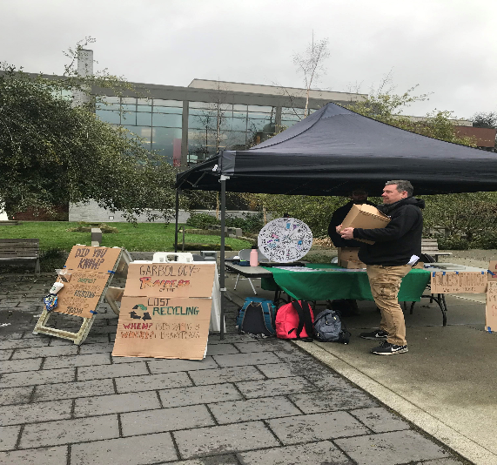
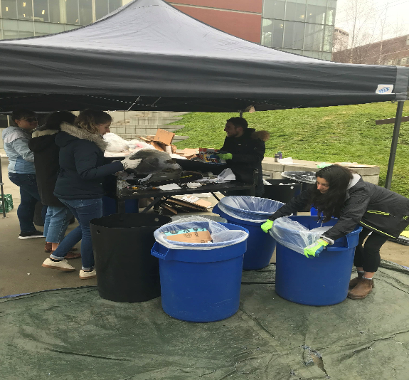

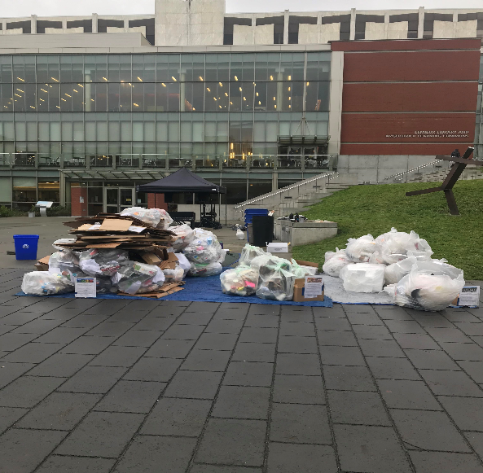

Annual Community Recycling Day

- The university also collected over 5000lbs of donation items and electronic recycling from Community Recycling Day 2019.

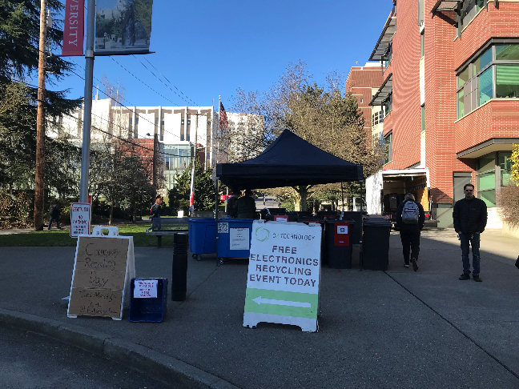

Final Recyclemania Scoreboard:

- 20th place with a final diversion rate (recycling plus composting) of 56.4%
  - Compare to last year’s first-ever performance of 6th place, with a final diversion rate of 74.8%

